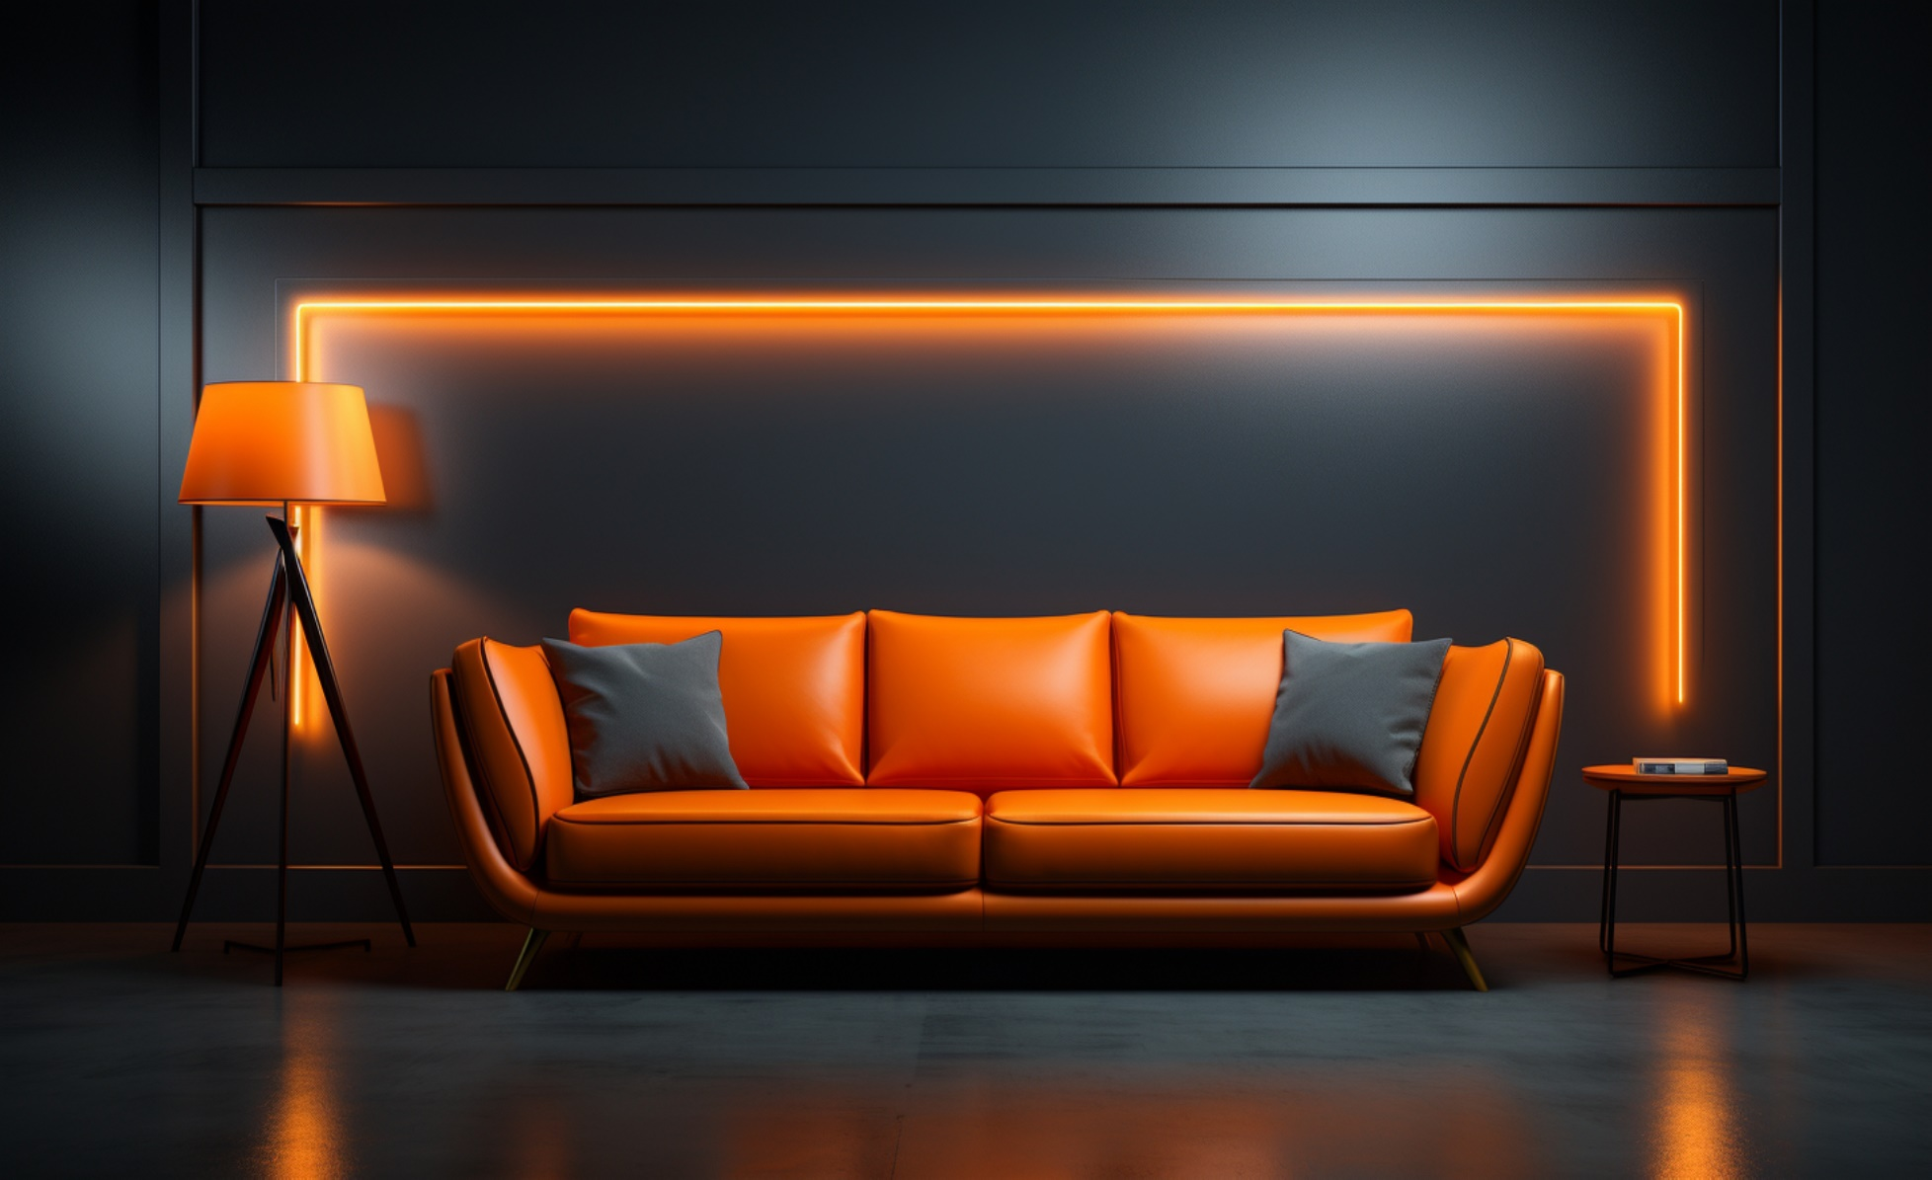

HOME PRODUCTS ABOUT US CONTACT US REGISTER

**VISIT SHOP**

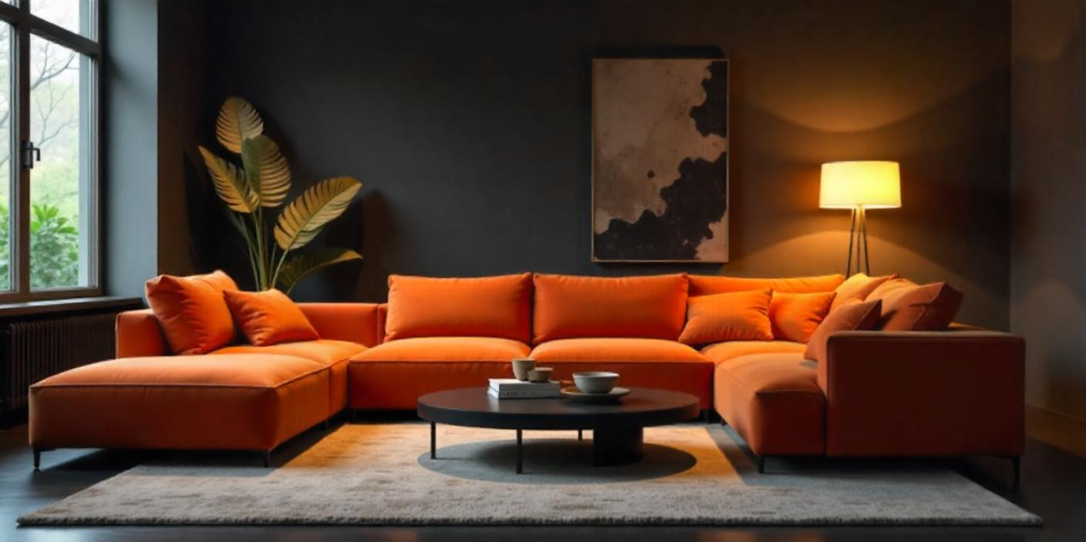

At Dream Home Furnishing, we believe that every home deserves furniture that combines style, quality, and comfort. Our collection is crafted to inspire, helping you create the home of your dreams, one piece at a time.

FURNISH YOUR DREAM

***Our Top Pick for You***

*BUY NOW 30%off*

*BUY NOW 30%off*

*BUY NOW 30%off*

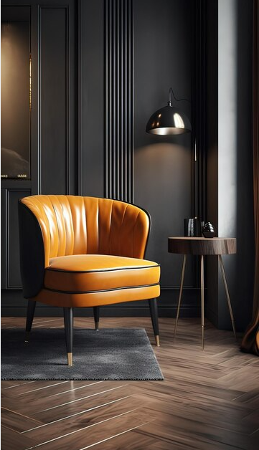

Create a platform where people can buy and sell pre-owned furniture. This promotes sustainability and can appeal to budget-conscious shoppers. promotes sustainability and can appeal to budget-conscious shoppers.

Create a platform where people can buy and sell pre-owned furniture. This promotes sustainability and can appeal to budget-conscious shoppers. promotes sustainability and can appeal to budget-conscious shoppers.

Create a platform where people can buy and sell pre-owned furniture. This promotes sustainability and can appeal promotes sustainability and can appeal to budget-conscious shoppers.

Create a platform where people can buy and sell pre-owned furniture. This promotes sustainability and can appeal to budget-conscious shoppers. promotes sustainability and can appeal to budget-conscious shoppers.

*BUY NOW 30%off*

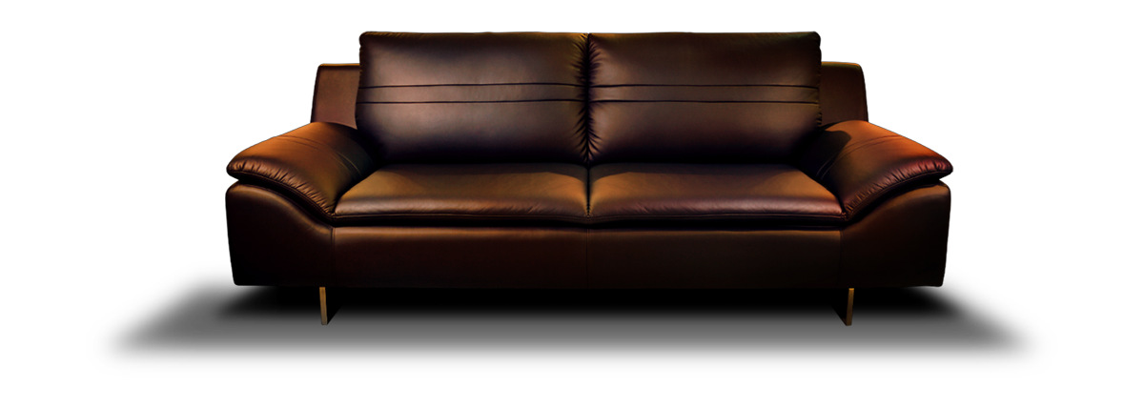

***Welcome to Furnish Your Dream***

*At Dream Home Furnishing, we believe that every home deserves furniture that combines style, quality, and comfort. Our collection is crafted to inspire, helping you create the home of your dreams, one piece at a time.*

***Product Categories***

V I E W M O R E **>**

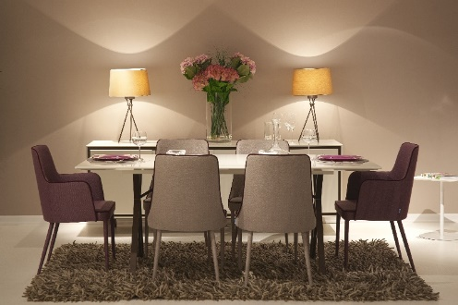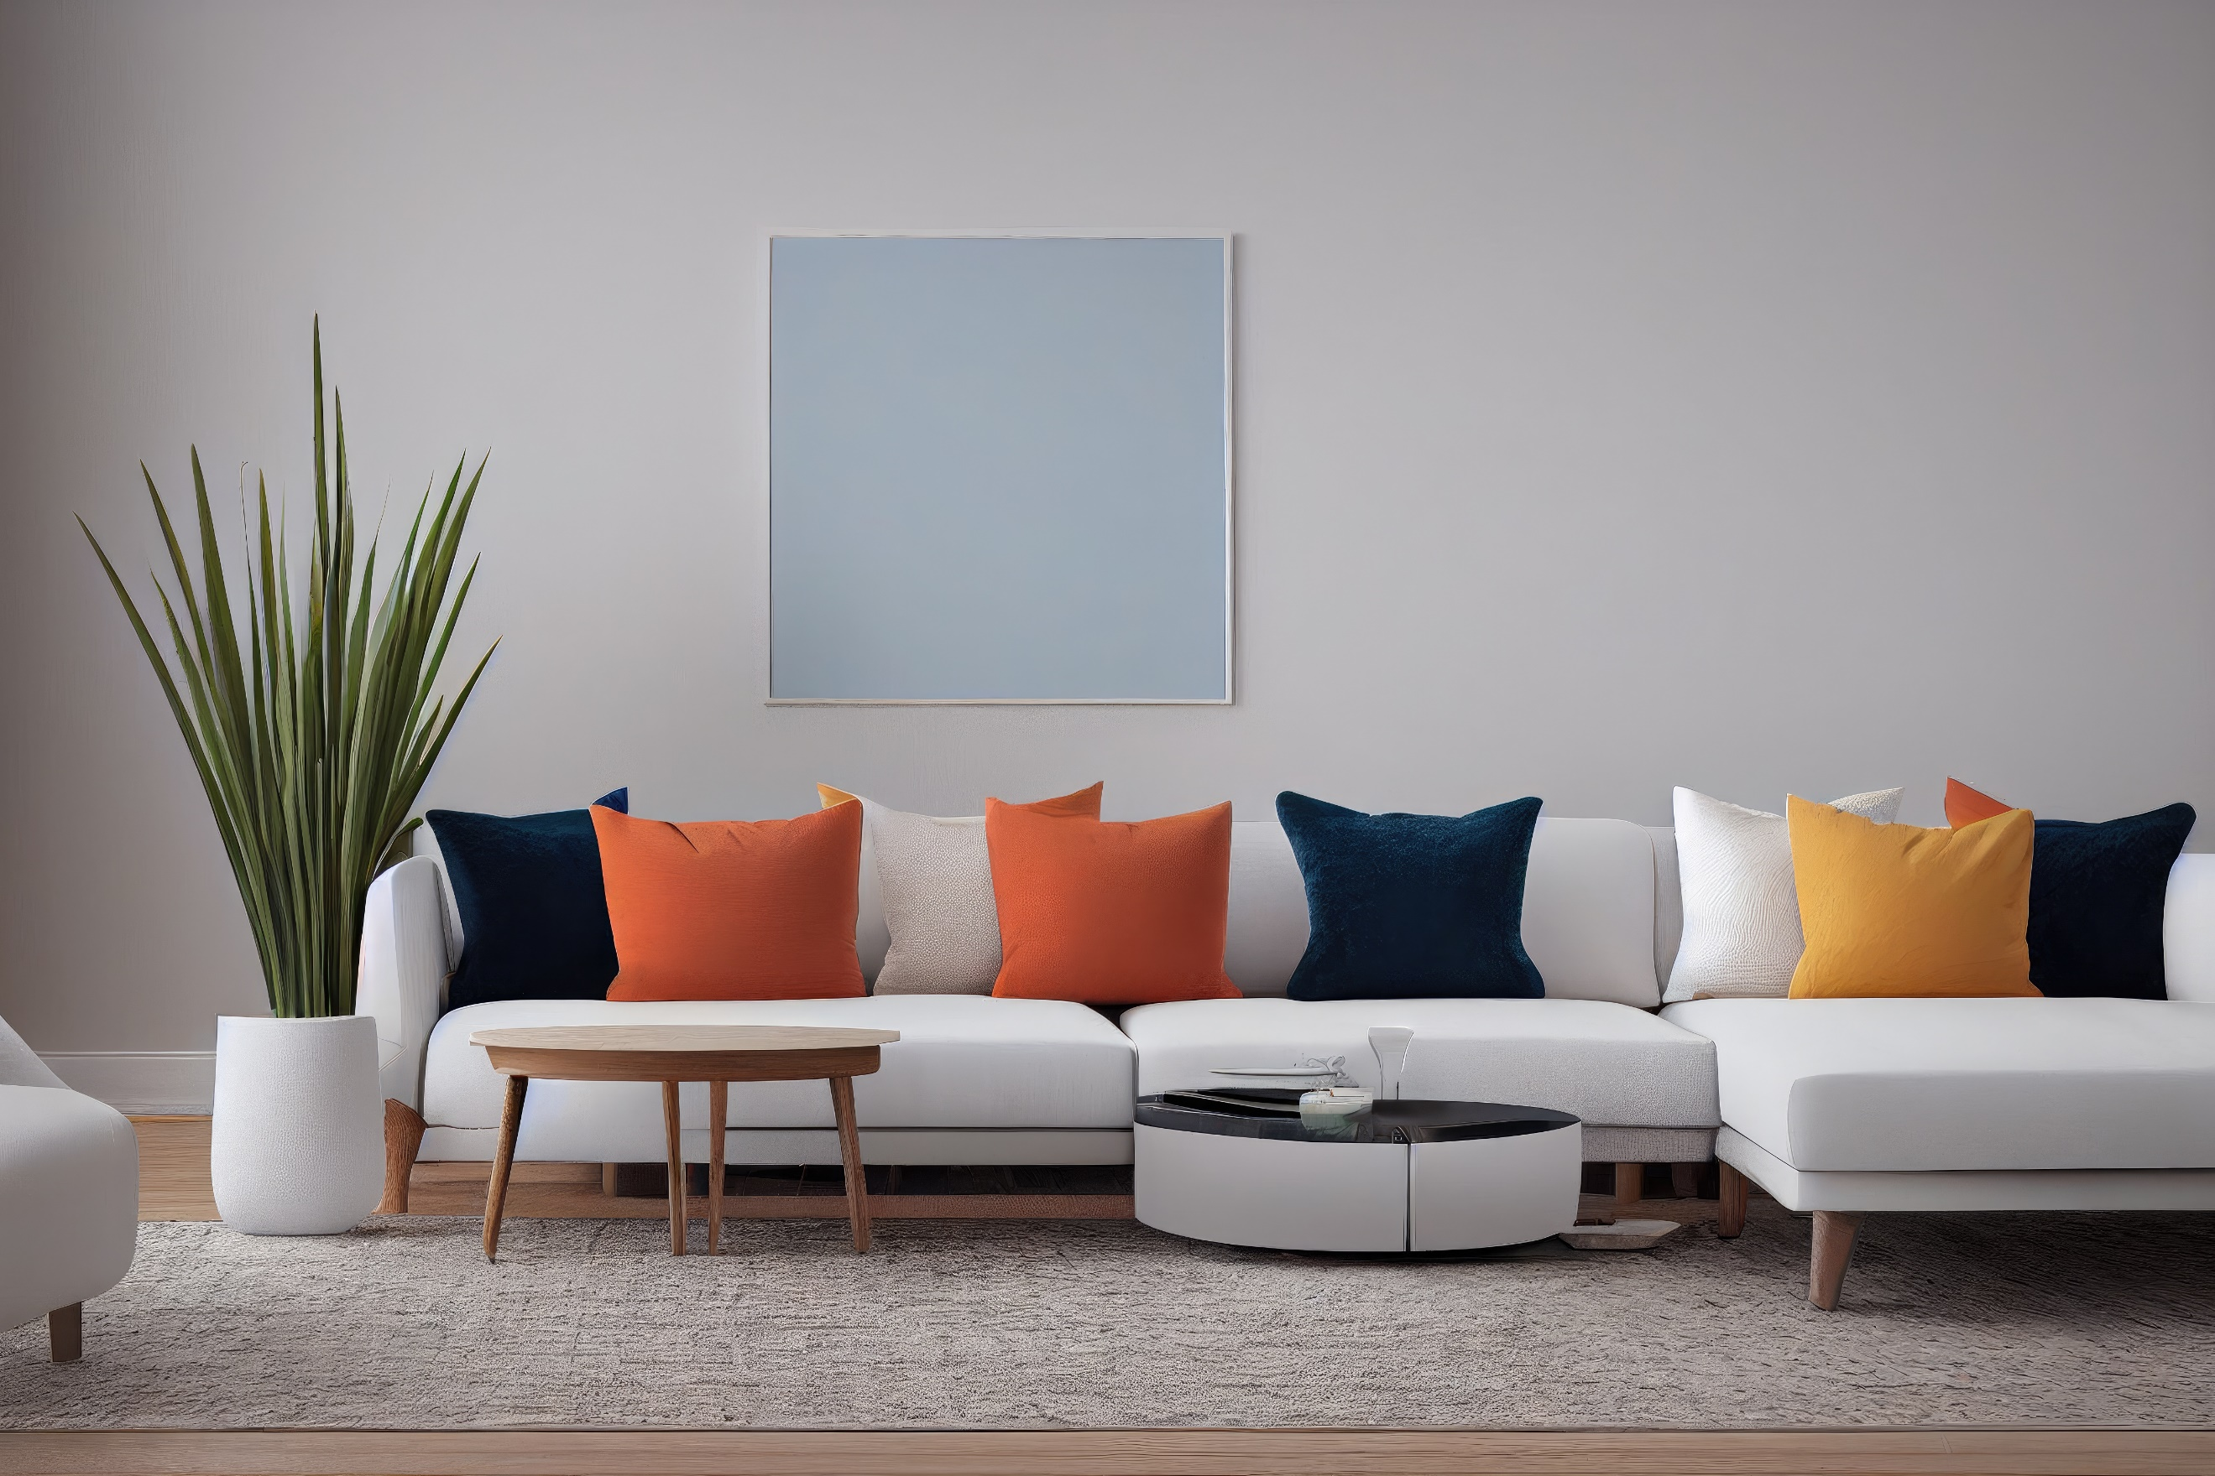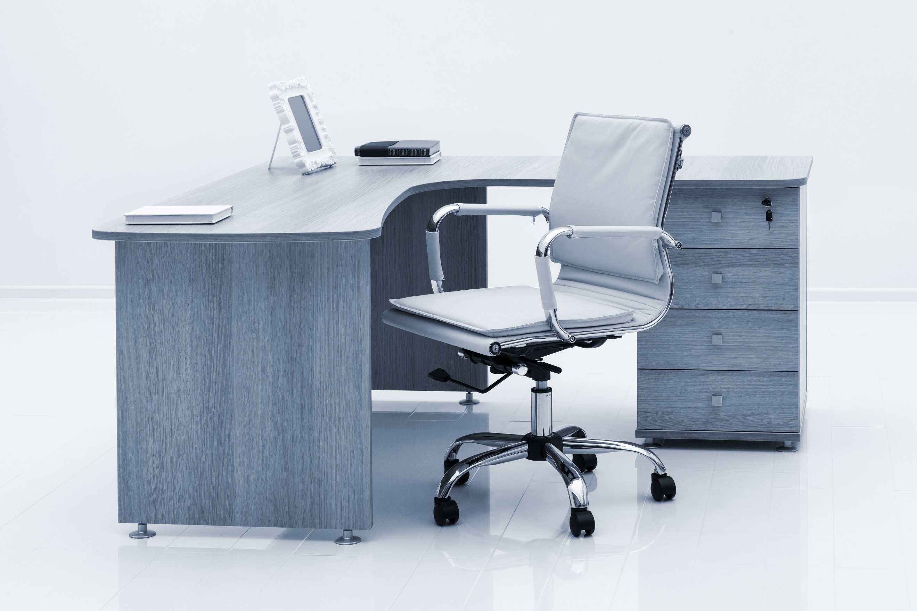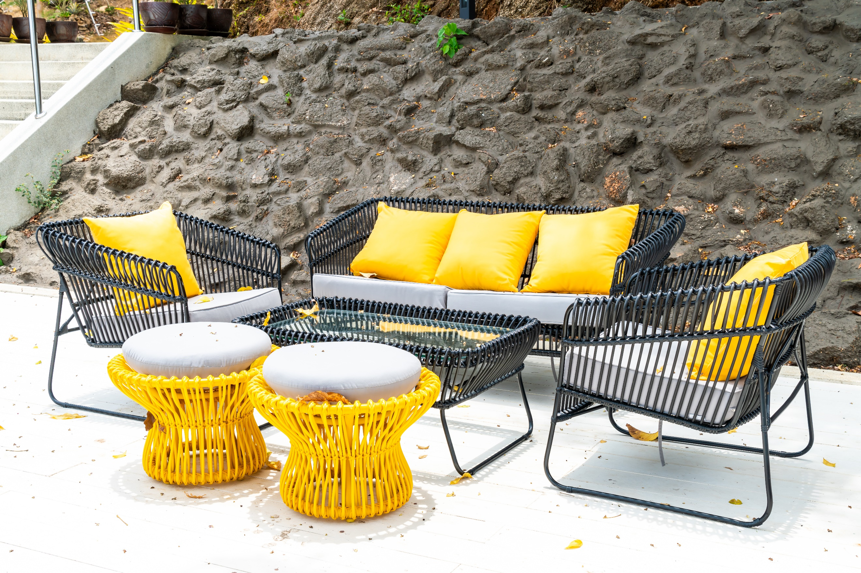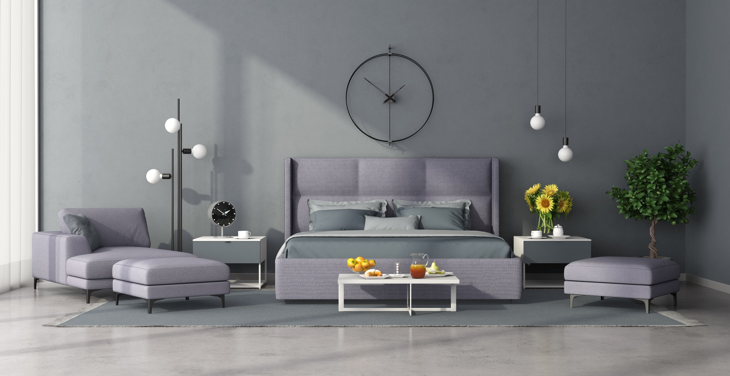

DINING ROOM

OFFFICE SETUP

OUTDOOR SETUP

BED ROOM

LIVING ROOM



**Our Service**

GENERAL CONTRACTING DESIGN & BUILD

INHOUSE PRODUCTION MANAGEMENT



We as commercial office fit out company know how to plan without compromising in design and visual appearance. We are heavily involved in corporate office interiors renovation and construction process and work closely with contractors and manufacturers to carry out detailed interior design concepts of the project including architectural details, lighting, floor and ceiling designs, interior furniture and due diligence. We demarcate the project's scope of work, draw schematics and blue prints, select the right materials, help the clients **with** office fit out, and oversee budgeting and scheduling.

***Our Customer Reviews***

“Dream Home Furnishing” exceeded my expectations! The quality and style are unmatched. Absolutely love my new living room set! The quality is fantastic, and it arrived right on time. It’s exactly what I envisioned for my space!

I was hesitant to buy furniture online, but Dream Home Furnishing exceeded my expectations. My new sofa is both stylish and comfortable. Will shop again the quality is fantastic, and it arrived right on time. It’s exactly what I envisioned for my space!

“Dream Home Furnishing” exceeded my expectations! The quality and style are unmatched Dream Home Furnishing makes shopping for furniture so easy. From browsing to delivery, every step was seamless. Plus, my office desk looks amazing!

**Olivia P.**

D**avid L.**

**Dr. Jane**



**Quick Links**

* Home
* Shop
* Categories
* About Us
* Contact
* Privacy Policy
* Terms & Conditions

**Address**  
Dream Home Furnishing  
[Insert Address Here]  
[Phone Number] | [Email Address]

[Pinterest Icon]

[Twitter Icon]

Follow Us

[Facebook Icon]

[Instagram Icon]

[Pinterest Icon]

[Twitter Icon]

***Bringing sophistication and elegance to your home.***

*At Dream Home Furnishing, we pride ourselves on our ability to combine innovative design with superior craftsmanship. Take a look at some of our featured projects, where our furniture has helped elevate spaces, creating homes that are not just lived in, but loved.*